Day 11

**Day 11**

1. Create a stored procedure GetCustomerLevel which takes input as customer number and gives the output as either Platinum, Gold or Silver as per below criteria.

Table: Customers

* Platinum: creditLimit > 100000
* Gold: creditLimit is between 25000 to 100000
* Silver: creditLimit < 25000

**Ans)**

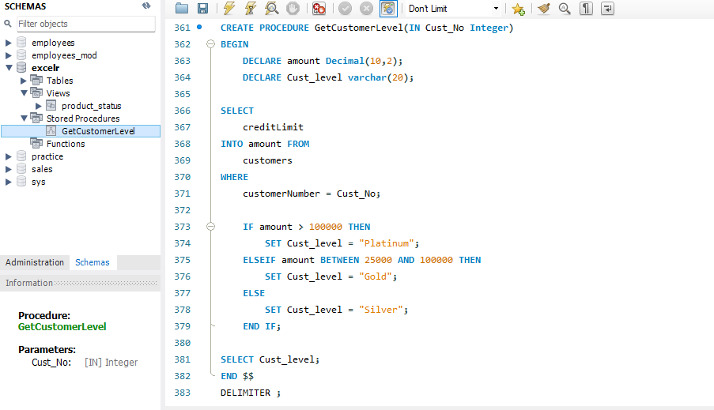

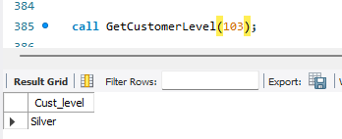

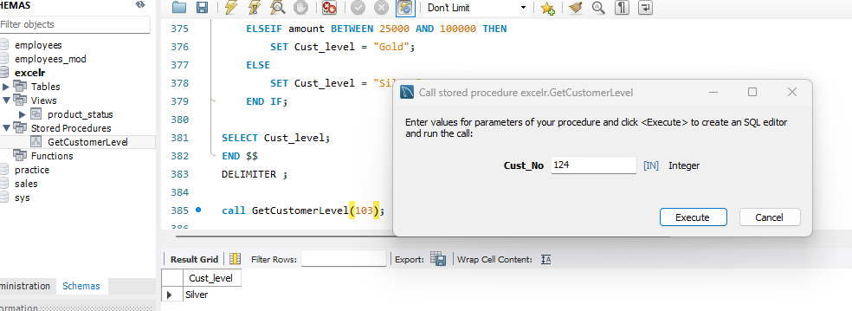

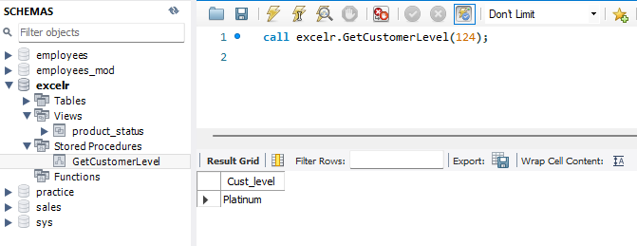

1. Create a stored procedure Get_country_payments which takes in year and country as inputs and gives year wise, country wise total amount as an output. Format the total amount to nearest thousand unit (K)

Tables: Customers, Payments



Ans)

